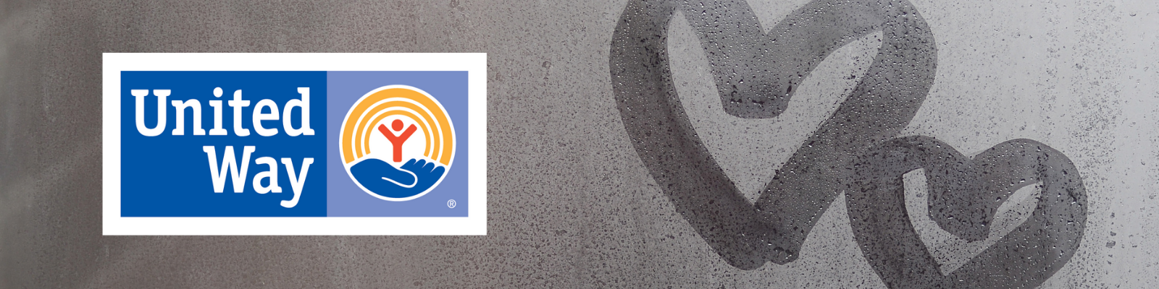

Welcome to your United Way Workplace Drive!
First and foremost, thank you for organizing and agreeing to host a United Way Workplace Drive. Workplace Giving Drives give your business the opportunity for employees to learn more and donate to causes that matter to them. United Way’s Workplace Drives are about bringing people together where they work to tackle our community’s most challenging issues – because no one person or organization can do it alone. Participating in a United Way drive also provides rewarding team building experiences through volunteerism. Whether a small business, a major corporation or even a non-profit organization, we are happy to have you join the many local businesses and organizations that run United Way Workplace Drives each year.

Getting Started
Every workplace drive is different and can be shaped around your organization’s culture. Setting up and running a drive is simple, and we can help you every step of the way.

On the pages to follow in this document, you will find a series of 6 strategic emails. These emails and images can simply be copied and pasted into your business’s email system and sent to all employees during your workplace drive. These emails allow you to engage and inform your employees of the work United Way is doing in your community. If you are following a two-week workplace drive schedule, you should send three emails a week.

Noteworthy items:
- These emails can be edited to suit your company and drive. Please feel free to make changes as you see fit.
- We have found that the first and last email in the series may be more powerful if it is sent from the local business leader.
- There are highlighted sections that you will need to fill out with your company information and individualized pledge link (If you chose the virtual option). Your link should have been sent to you via email with this document, if not please email Danielle at the contact below.
- These were strategically written to engage your employees with United Way, it is important that these emails or some other form of communications that you create be sent with the virtual pledge link to be most successful.

Again, we are very grateful that you have chosen to host and organize a United Way Workplace Drive. If you have any questions, concerns, or issues please contact Danielle Isbell, Director of Resource Development, at disbell@uwwv.org or 812-235-6287.

Email Communication 1 – “Kickoff”:
Subject Line: United Way Workplace Drive Kickoff

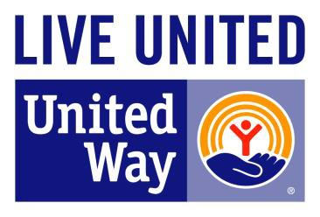
Dear Colleagues,
To say that the last year and half has been unusual would be an understatement. The coronavirus has completely changed our lives and the community we live in, while it continues to cast a dark cloud of uncertainties all around us. Everyday struggles in the Wabash Valley have been amplified by the pandemic and families who were already struggling to get by now find themselves in even more hardships. As employees of COMPANY NAME and caring residents in this community, we share a common hope for the Wabash Valley to be a thriving place where everyone has the opportunity to live a safe, stable and successful life.
United Way of the Wabash Valley’s mission and Bold Goal to move 10,000 families out of financial struggles and into stability, offers us a great way to learn about and engage in meaningful philanthropy that can truly address the issues in our community. Each year, United Way reaches out to businesses like ours to advocate on a community-wide mission and seek support. Now more than ever, our participation is needed and we must LIVE UNITED.
Like many other things during this global pandemic, our drive for United Way will be VIRTUAL (or Hybrid)! By using a virtual platform and a series of e-mails, we hope to provide our employees the opportunity to learn how United Way is using donor-resources to address the contributing social issues that lead to generational poverty. In this same virtual method, you will have a chance to join their work with your donation if you choose. All employees who wish to donate or learn more about United Way and their work in the community can click this link (LINK) to access their pledge form. Our workplace drive will run from DATES.
Together, our gifts will be invested in strategies designed to break the cycle of generational poverty and support struggling working families. Great things are happening and their work is advancing. We can’t stop now. Our collaborative support aids the work of United Way in our community.

There will be more emails sent throughout our drive that will allow us all to learn more about the great work United Way is doing in our community! Now more than ever, let’s all continue our commitment by giving generously this year.
Sincerely,

Business Leader NAME

Email Communication 2 – “Why United Way”:
Subject Line: Who is United Way?

UNITED, We Fight Poverty!

Everyday life is tough for struggling families in a “normal” year, but now with the added stresses of COVID-19, even more of our neighbors are continuing to struggle. There is no “one size fits all” answer, and no one person or organization can do it alone. That is why United Way uses a collective impact approach with passionate volunteers and organizations to tackle the complex issue of poverty and the struggles of working families within the Wabash Valley.

How do they achieve their goal of moving 10,000 households out of financial struggles? They do it by:
- Partnering with local businesses and the community
- Convening local experts
- Creating community solutions with partners
- Measuring and Reporting the impact we make together

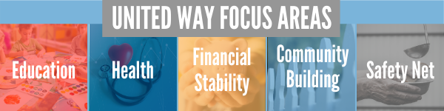

United Way partners with local organizations, an open process to any organization that meets the required guidelines. Their collective impact approach addresses people’s immediate needs but also works collaboratively with other partners in the community toward changing systems so that people can avoid challenges altogether. This includes new grant processes to support collaborative approaches to addressing poverty in the region. It is about investing in the present as well as the future.

Watch this VIDEO to learn more!

Please click this link (LINK) to access your virtual pledge form and to learn more about COMPANY NAME’s United Way Workplace Drive. Last day to participate is DATE.

Email Communication 3 – “Safety Net Services and COVID-19 Relief”:
Subject Line: Helping People Tomorrow AND Today!

While United Way of the Wabash Valley has a long-term bold goal to change the face of our community, they know that even today there are many individuals and families living in our communities are walking a financial tightrope—barely surviving let alone trying to save for a home, college, or retirement. Many children and their hardworking parents know too well what it’s like to live without. Without food or a place to call home. Without a job that offers advancement opportunities. Without a doctor. Without the knowledge that college is an option. Without opportunity.
That’s why United Way still keeps a focus on the safety net services. Fortunately, poverty and even minor financial struggles do not have to be a fixed state. Roughly half of those who reach the poverty level will get out within a year. COVID-19 has proven that sometimes life can create an immediate need for help. “Safety Net Services” are those emergency services that are vital such as food, shelter, and clothing, and 25% of United Way’s community investments are still dedicated to this work. While those services may not provide a long-term solution to reducing the cycle of poverty, they are still a vital first step on the pathway to success.
The COVID-19 pandemic highlighted the importance of Safety Net Services. In March 2020, the United Way of the Wabash Valley collaborated with the Wabash Valley Community Foundation to start the Wabash Valley COVID-19 Emergency Relief Fund to quickly begin to address the growing need.
Later in 2020 and early 2021, the Safety Net Council also combined their resources with the COVID Relief Fund so that as we approach the end of 2021, the United Way has been able to provide grants to more than 100 different organizations totaling over $2,000,000 in COVID and Safety Net relief services. From putting food on a family’s table, to providing safe and healthy child care for essential workers, to converting vital behavioral health services into telemedicine…. the United Way funds are still working on the immediate needs.
Our Safety Net Impact Council will ensure that these kinds of services and service organizations remain as a solid base of support in our community while our other councils look at long-term solutions. We need our community, now more than ever to step up and support one another. United Way is a great opportunity to invest in both short-term relief and long-term solutions for our community with a donation. Their collaborative work is getting resources to people who need it today, while still addressing the long-term needs of our community.
Click this link (LINK) to learn more about United Way’s work and access your COMPANY NAME’s United Way virtual pledge form. The last day to participate in our workplace drive is DATE.

Watch this VIDEO to learn more and hear stories from community partners.

Email Communication 4 – “United Way Impact Councils”:
Subject Line: Learn About UWWV Impact Councils

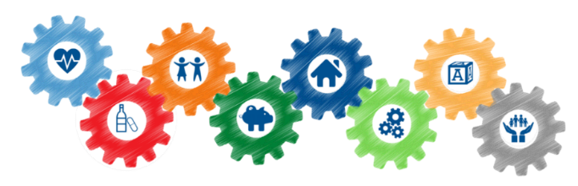
To achieve success on a community Bold Goal, United Way utilizes a collective impact model where multiple organizations are working together to solve a specific issue in a structured form of collaboration. To achieve change, United Way has created 8 Impact Councils to help move households out of financial struggles and into stability. Volunteers recommend and monitor the investments of United Way donor resources in order to bring successful results to their specified outcome targets in support of the overall community goal to move 10,000 households to financial stability. Click HERE to learn more about the work of the Councils.

The councils make the magic happen. They develop ways to invest United Way resources in our community and many funded partners help us to move the needle on household financial stability. What have our Impact Councils been doing?
Success By 6
- Created over 200 high-quality openings in local childcare facilities
- Supporting future teachers earning their early childhood education credential
- Providing reading programs and books to children across the Wabash Valley including Real Men Read
- Supporting the start-up and family programming for the new Deming Early Learning Center
Substance Use Disorder
- Provided training for over 50 Peer Recovery Specialists
- Mentoring to over 100 children in the juvenile justice system
- Programs for youth to promote substance use prevention
- Collaborative HRSA Grant to bring services to rural areas to combat substance use
Youth Success
- Awarded 16 mini-grants to organizations working with students to promote engagement and attendance
- Investing in supports for student education transitions, such as elementary to middle school
Financial Management
- Providing financial literacy training, coaching, and mentoring to families to help break the cycle of poverty
- Exploring low barrier banking options for the community
Strong Neighborhoods
- Awarded 15 mini-grants for neighborhood improvement projects
- Creating connections with neighborhoods to drive future initiatives
United Way’s two newest councils are just getting underway in 2021:
Job Skills and Community Health
- With our community’s continuing support, investments from these councils will be coming soon

The hard work of these councils is not possible without donor support. Click this link (LINK) to learn more about United Way’s work and access United Way virtual pledge form. The last day to participate in our workplace drive is DATE.
Email Communication 5 – “Incentives”:
Subject Line: Want to WIN $10,000?
You can WIN $10,000!
Yes, you read that right! This year one lucky donor to United Way of the Wabash Valley will win $10,000 because of their support to the United Way. Terre Haute Chevrolet has partnered with United Way to donate a $10,000 cash incentive to the lucky donor.
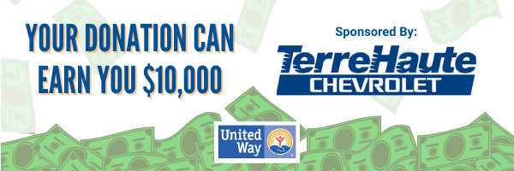
Here is how you earn entries:
- Any returning donor at same level as last year or more = 1 entry
- Every $25 increment donation from a new donor = 2 entries
- Every $25 increment increase from a previous year donor over their last year’s gift = 2 entries
- An added bonus with any new or increased gift reaching $500 or more = 20 additional entries
You can DOUBLE your donation!
Through a grant from the Indiana United Ways funded from the Lilly Endowment, donors making new gifts or increased gifts of $100 or more will be matched dollar for dollar! This is doubling the impact we can make in the Wabash Valley. If a company can increase their workplace participation by 5 percentage points, the grant will match the ENTIRE workplace drive (everything we raise here at [COMPANY NAME] up to $50,000).
Click here to pledge: LINK
Become a Part of the Vanguard Society!
Members of The Vanguard Leadership Giving Program are individuals truly dedicated to shaping our corner of the world today and tomorrow. The Society includes donors who contribute $1,000 or more to United Way each year. They may come from different backgrounds and do different things, but they come together as one for the community. Choose the United Way leadership giving group that’s right for you.
Foundation: $1,000 Cornerstone: $2,500
Pillar: $5,000 Keystone: $7,500
Tocqueville Society $10,000 Tocqueville Pillar: $25,000

Email Communication 6 – “Wrap-up”:
Subject Line: UWWV Drive is Coming to an End, Please Pledge Today!
Dear Colleagues,
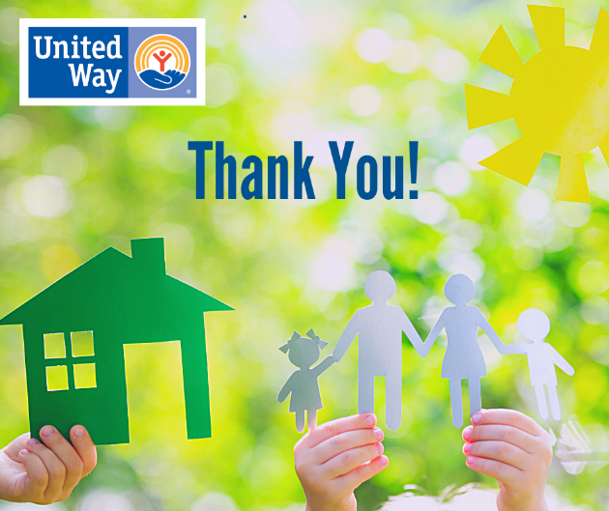
As we are wrapping up our United Way VIRTUAL Resource Drive, we hope all of our employees have had the time to learn more about how our local United Way is taking a new approach for a long-term bold goal for our community. I hope you have considered investing in their collaborative initiatives in the Wabash Valley.
United Way’s bold goal to move 10,000 families out of financial struggle and into stability is providing focused support for struggling working families through education, health and financial stability initiatives. This makes it so clear that our local United Way is not about a money goal, but rather a people goal. This is why [COMPANY NAME] wants our employees to know that we have the chance to invest in our future.
When you donate to United Way, you are touching someone’s life, and you create a ripple effect that strengthens our entire community. We must band together and we must LIVE UNITED. The last opportunity to fill out your virtual pledge form is [date], so please click LINK if you have not already donated or want to learn more. Thank you so much for taking the time to learn about United Way and how you can help. Small things really do matter. A donation to the United Way can change the face of our Wabash Valley.
Sincerely,
Business Leader NAME

