Week 1

Thank you to everyone who attended our United Way Kick-off Meetings this week. We are fortunate to work for a company that has chosen to Join the Fight in our community, joining fellow businesses and their employees in United Way’s goal to move 10,000 Wabash Valley households to financial stability.

If you missed our United Way Kick-off, please take a look at the videos here to learn more about ALICE in our community and United Way’s fight against poverty. United Way of the Wabash Valley is unique in the way it makes an impact in the community. United Way’s history of leadership enables them to spearhead comprehensive, community-wide change.

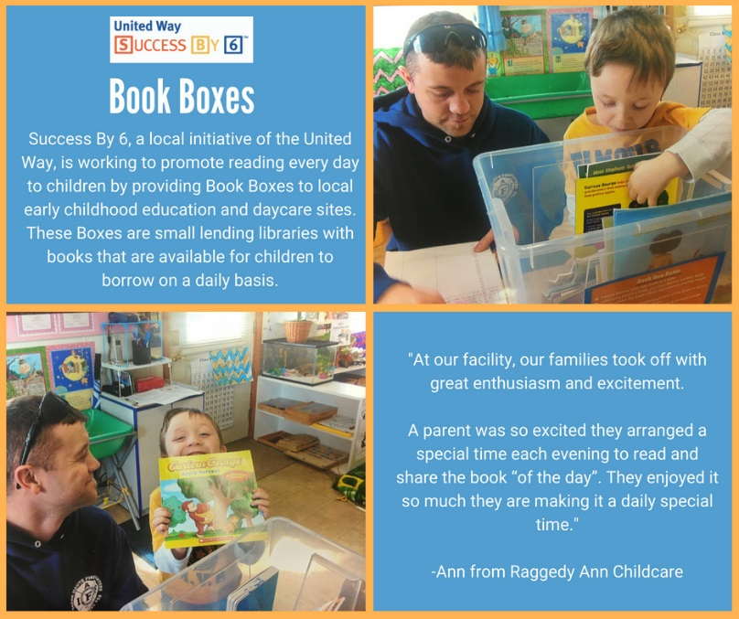
As we learned, the fight against poverty takes many forms. One of the focus areas for United Way is their Success By 6 initiative to promote early childhood development to ensure children enter school ready to succeed.

Just a small program to increase parents reading with children can lead to a break in the cycle of poverty in our community. A small investment of just $50 can provide a United Way “Book Box” at a childcare facility in our community.

During our United Way Resource Drive over the next few weeks, we hope you will choose to Join the Fight.

Please turn in your pledge card to [name] by [date] to be eligible for our incentives.

Thanks, and have a great week.

Week 2

Our local United Way wants you to meet ALICE. A multi-state study—completed by Rutgers University in partnership with United Ways around the country—showed a growing segment of our population in the Wabash Valley is working, but not able to attain financial stability. The ALICE Report can help our community understand how poverty is more than a federal government statistic, and involves real, struggling working families.

ALICE is an acronym that means Asset Limited, Income Constrained, Employed. To break our cycle of generational poverty, we must get past the stigma that poverty is about laziness or lack of will power.

There is no “one size fits all” answer, and no one person or organization can do it alone. United Way is building a collective movement of people and organizations to tackle the complex issue of poverty and the dilemma of struggling working families within our community.
When you touch someone’s life through your support of United Way’s Community Impact Fund, you create a ripple effect that strengthens our entire community. Please restore HOPE with your actions and help United Way move 10,000 families to financial stability.

If you would like to donate, please turn in your pledge card to [name] by [date] to be eligible for our incentives.

Thanks, and have a great week.

Week 3

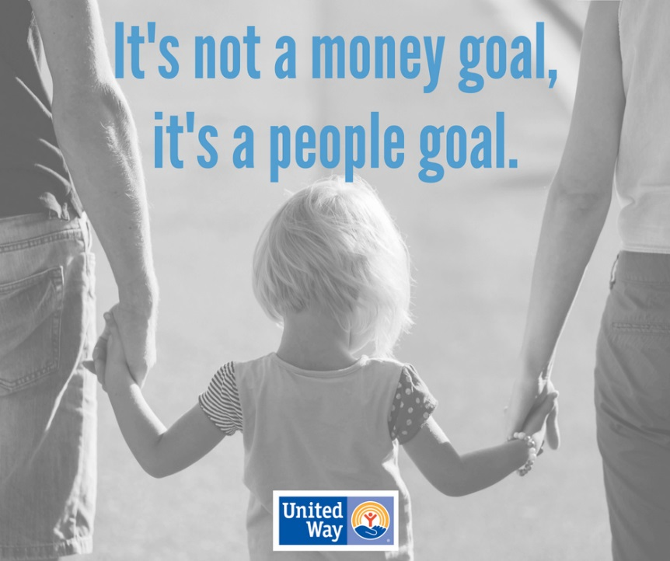
We’re wrapping up our United Way Resource Drive this week and we hope all of our employees have had the time to learn more about United Way and consider investing in the Community Impact Fund. We’re hopeful that many will Join the Fight against poverty in the Wabash Valley.

United Way’s new direction and bold goal to decrease our ALICE population (www.unitedwayalice.org) by providing focused support for struggling working families makes it so clear that our local United Way is not about a money goal, but rather a people goal. This is why our company wants employees to know what its all about and have the chance to invest in our future.

Have ever found yourself wondering why we go through the effort of this United Way drive each year, when seemingly many issues and challenges should seem to take higher priority? We know that our business must be about more than just the “widgets” we make. Our employees spend more time living and growing in this community we call home than they do here at our workplace. Therefore, we join hundreds of other local businesses in doing our part to improve this community we call home and asking our employees to Join the Fight.

The last opportunity to turn in a pledge card is [date], so please submit them to [name]. Thank you so much for taking the time to learn about United Way and how you can help. Small things really do matter. A donation to the Community Impact Fund really can change the face of our Wabash Valley.

