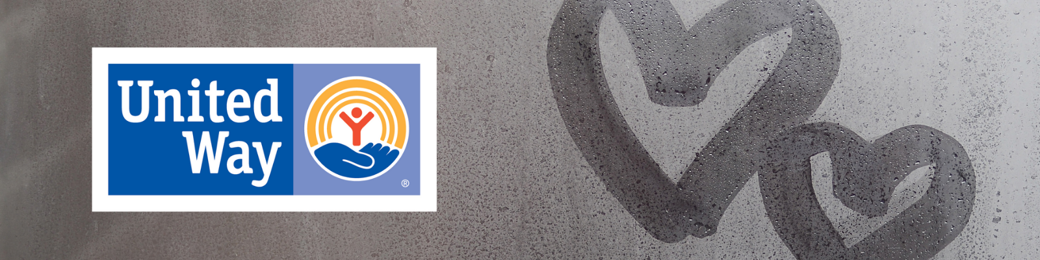

Welcome to your United Way Workplace Drive!
First and foremost, thank you for organizing and agreeing to host a United Way Workplace Drive. Workplace Giving Drives give your business the opportunity for employees to learn more and donate to causes that matter to them. United Way’s Workplace Drives are about bringing people together where they work to tackle our community’s most challenging issues – because no one person or organization can do it alone. Participating in a United Way drive also provides rewarding team building experiences through volunteerism.

Whether a small business, a major corporation or even a non-profit organization, we are happy to have you join the many local businesses and organizations that run United Way Workplace Drives each year.

Getting Started
Every workplace drive is different and can be shaped around your organization’s culture. Setting up and running a drive is simple, and we can help you every step of the way.

On the pages to follow in this document, you will find a series of 6 strategic emails. These emails and images can simply be copied and pasted into your business’s email system and sent to all employees during your workplace drive. These emails allow you to engage and inform your employees of the work United Way is doing in your community. If you are following a two-week workplace drive schedule, you should send three emails a week.

Noteworthy items:
- These emails can be edited to suit your company and drive. Please feel free to make changes as you see fit. Email #4: Investments can also be customized to a focus area that your company and/or employees are passionate about. If you would like to highlight education, health or safety net programs please email Danielle and we will provide that for you.
- We have found that the first and last email in the series may be more powerful if it is sent from the local business leader.
- There are highlighted sections that you will need to fill out with your company information and individualized pledge link. Your link should have been sent to you via email with this document, if not please email Danielle at the contact below.
- These were strategically written to engage your employees with United Way, it is important that these emails or some other form of communications that you create be sent with the virtual pledge link to be most successful.

Again, we are very grateful that you have chosen to host and organize a United Way Workplace Drive. If you have any questions, concerns, or issues please contact Danielle Isbell, Director of Resource Development, at disbell@uwwv.org or 812-235-6287.
Email Communication 1 – “Kickoff”:
Subject Line: United Way Workplace Drive Kickoff

Dear Colleagues,
To say that 2020 has been an unusual year is an understatement. The coronavirus has completely changed our lives and the community we live in, while it continues to cast a dark cloud of uncertainties all around us. Everyday struggles in the Wabash Valley have been amplified by the pandemic and families who were already struggling to get by now find themselves in even more hardships. As employees of COMPANY NAME and caring residents in this community, we share a common hope for the Wabash Valley to be a thriving place where everyone has the opportunity to live a safe, stable and successful life.
United Way of the Wabash Valley’s new mission and Bold Goal to move 10,000 families out of financial struggles and into stability, offers us a great way to learn about and engage in meaningful philanthropy that can truly address the issues in our community. Each year, United Way reaches out to businesses like ours to advocate on a community-wide mission and seek support. Now more than ever, our participation is needed and we must LIVE UNITED.
Like many other things during this global pandemic, our drive for United Way will be unlike any other that has come before. Under the social distancing and infection control guidelines we have moved our resource drive to be VIRTUAL! By using a virtual platform and a series of e-mails, we hope to provide our employees the opportunity to learn how United Way is using donor-resources to address real time issues in our community. In this same virtual method, you will have a chance to join their work with your donation. All employees who wish to donate or learn more about United Way and their work in the community can click this link (LINK) to access their pledge form. Our workplace drive will run from DATES.
Together, our support will help United Way in their work towards their Bold Goal. Our gifts will be invested in strategies designed to break the cycle of generational poverty and support struggling working families. Great things are happening and their work is advancing thanks to our past generosity. We can’t stop now. Though we do not know what the coming hours, days and weeks may hold in the face of a growing pandemic, we do know that our collaborative support aids the work of United Way in our community.

There will be more emails sent throughout our drive that will allow us all to learn more about the great work United Way is doing in our community! Now more than ever, let’s all continue our commitment by giving generously this year.

Sincerely,

Business Leader NAME

Email Communication 2 – “Why United Way”:
Subject Line: Who is United Way?

UNITED, We Fight Poverty!

Every day life is tough for struggling families in a “normal” year, but now with the added stresses of COVID-19, even more of our neighbors are struggling. There is no “one size fits all” answer, and no one person or organization can do it alone. That is why United Way uses a collective impact approach with passionate people and organizations to tackle the complex issue of poverty and the struggles of working families within the Wabash Valley.

How do they move 10,000 households out of financial struggles and into stability? They do it by:
- Partnering with local businesses and the community
- Convening local experts
- Creating community solutions with partners
- Measuring and Reporting the impact we make together

United Way accomplishes their work through impact councils based in focus areas. These volunteer-led councils bring together subject matter experts, people who are passionate about the issue, people whose lives are affected by the issue, business leaders, and organizations working to affect each area. The councils recommend and monitor the investment of United Way resources to bring successful results to their targeted goals in support of the overall community goal to move households to financial stability.

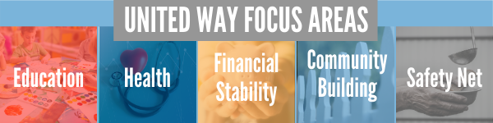

Watch this short video to learn how United Way is fighting for our community:
https://vimeo.com/287308379

Please click this link (LINK) to access your virtual pledge form and to learn more about COMPANY NAME’s United Way Workplace Drive. Last day to participate is DATE.

Email Communication 3 – “COVID-19 Impact by UWWV”:
Subject Line: Now More Than Ever!

In March, the United Way of the Wabash Valley witnessed the effects the COVID pandemic was beginning to create on our community. Their work centers around helping struggling working families in our community, and the problems were just getting bigger. Individuals and families who had not struggled before are now relying on the help of local organizations and putting more pressure on our community for support.
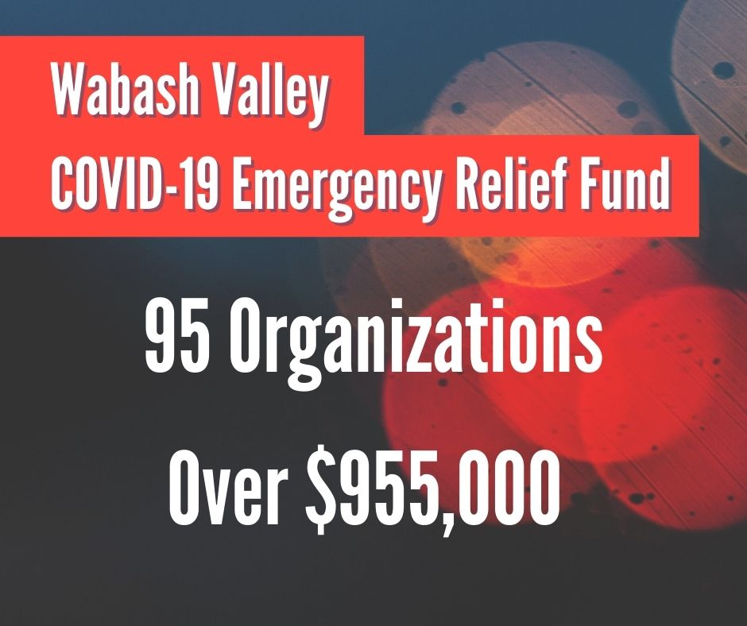
In response, the United Way pivoted and put all their energy into getting needed resources to organizations that were providing front-line help to those struggling the most. They were able to immediately mobilize resources to address the quickly evolving needs of our vulnerable neighbors by creating the Wabash Valley COVID-19 Emergency Relief Fund. In these last 6+ months, the fund has been able to provide grants to over 95 different organizations totaling more than $955,000. From putting food on a family’s table, to providing safe and healthy child care for essential workers, to converting vital behavioral health services into telemedicine…. the fund is working on the immediate need.
But the need is still there! We need our community, now more than ever to step up and support one another. United Way is a great opportunity to invest in both short-term relief and long-term solutions for our community with a donation. Their collaborative work is getting resources to people who need it today, while still addressing the long-term needs of our community.
Click this link (LINK) to learn more about United Way’s work and access your COMPANY NAME’s United Way virtual pledge form. The last day to participate in our workplace drive is DATE.

Email Communication 4 – “UWWV Investments”:
Subject Line: Learn About UWWV Investment Opportunities
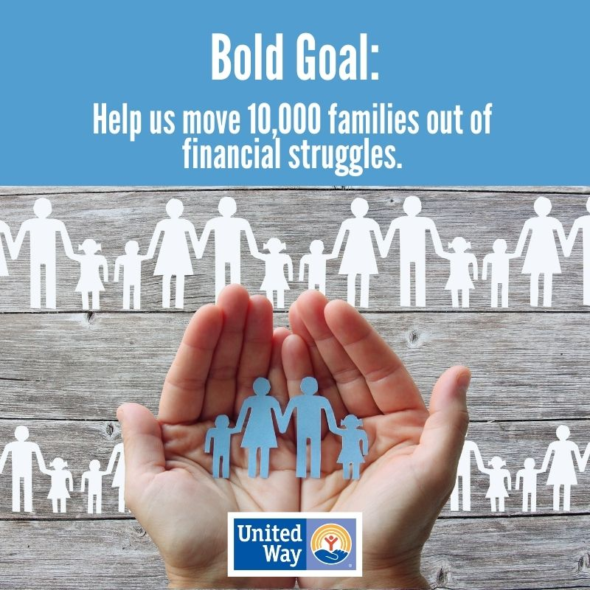
To achieve success on a community Bold Goal, United Way has shifted to a collective impact model. This is where multiple organizations are working together to solve a specific issue in a structured form of collaboration. To achieve social change though collective impact, United Way has created Impact Councils and currently has six of those councils working to help move households out of financial struggles and into stability. Members of these councils recommend and monitor the investments of United Way donor resources in order to bring successful results to their specified outcome targets in support of the overall community goal to move 10,000 households to financial stability. Learn more about the work of the councils here: https://uwwv.org/our-work/

United Way has multiple investment opportunities, including all of their community partners, for all donors. We’d like to highlight one of their newest investment initiatives in their Financial Stability focus area. The Financial Management Impact Council delivers income management tools, mentoring, and programs for the entire community by meeting families “where they are.” The Council knows that many in our community are struggling to make ends meet, but they also know that in order to break that cycle people must be informed about how to handle their finances. They want to see that throughout the Wabash Valley, households of all income levels have access to and can utilize the tools and assistance opportunities to allow them to build their financial stability.

The Council has recently made $100,000 available for any organization that will expand or provide financial literacy training, coaching, and/or mentoring in the Wabash Valley to help break the cycle of poverty in our community. If you would like to help fund this initiative (or any other focus area), you can designate your gift to Financial Stability on your virtual pledge form here: LINK

Last day to donate in our workplace drive is DATE.

Email Communication 5 – “Incentives”:
Subject Line: Two Great Incentives; Making 2020 a Year to Join Now More than Ever!

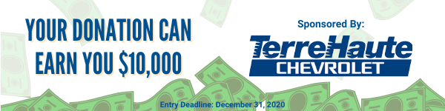
You can WIN $10,000!
Yes, you read that right! This year one lucky donor to United Way of the Wabash Valley will win $10,000 because of their support to the United Way. Terre Haute Chevrolet has partnered with the United Way to donate a $10,000 cash incentive to the lucky donor.
Here is how you earn entries:
- Any returning donor at same level or more = 1 entry
- Every $25 increment donation from a new donor = 2 entries
- Every $25 increment increase from a previous year donor over their last year’s gift = 2 entries
- An added bonus with any new or increased gift reaching $500 or more = 20 additional entries
You can DOUBLE your donation!
Through a grant from the Indiana United Ways funded from the Lilly Endowment, donors making new gifts or increased gifts of $100 or more will be matched dollar for dollar! This is doubling the impact we can make in the Wabash Valley.
If a company can increase their workplace participation by 5 percentage points, the grant will match the ENTIRE workplace drive (everything we raise here at [COMPANY NAME] up to $50,000).
Donating in a pandemic is safe with our new virtual pledge form! Click here to pledge: LINK
Become a Part of the Vanguard Society!
Members of The Vanguard Leadership Giving Program are individuals truly dedicated to shaping our corner of the world today and tomorrow. Vanguards are donors who contribute $1,000 or more to United Way each year. We come from different backgrounds and do different things, but we come together as one for the community. Choose the United Way leadership giving group that’s right for you.
Foundation: $1,000 Cornerstone: $2,500
Pillar: $5,000 Keystone: $7,500
Tocqueville Society $10,000 Tocqueville Pillar: $25,000

Email Communication 6 – “Wrap-up”:
Subject Line: UWWV Drive is Coming to an End, Please Pledge Today!
Dear Colleagues,
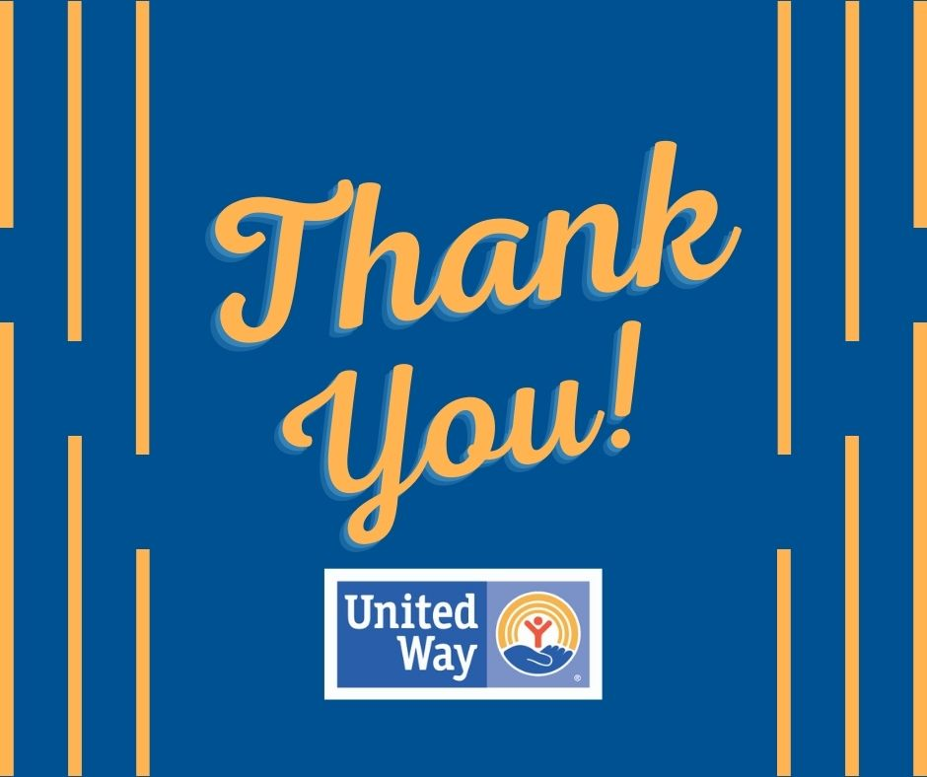
As we are wrapping up our United Way VIRTUAL Resource Drive, we hope all of our employees have had the time to learn more about how our local United Way is taking a new approach for a long-term bold goal for our community. I hope you have considered investing in their collaborative initiatives in the Wabash Valley. We’re hopeful that many will Join the Fight, now more than ever, against financial instability in the Wabash Valley.
United Way’s new direction and bold goal to move 10,000 families out of financial struggle and into stability is providing focused support for struggling working families through education, health and financial stability initiatives. This makes it so clear that our local United Way is not about a money goal, but rather a people goal. This is why [COMPANY NAME] wants our employees to know that we have the chance to invest in our future.
When you donate to United Way, you are touching someone’s life, and you create a ripple effect that strengthens our entire community. These are difficult times, and many of us may be facing challenges of our own, but now more than ever we must band together and we must LIVE UNITED.
The last opportunity to fill out your virtual pledge form is [date], so please click LINK if you have not already donated or want to learn more. Thank you so much for taking the time to learn about United Way and how you can help. Small things really do matter. A donation to the United Way can change the face of our Wabash Valley.
Sincerely,
Business Leader NAME

